**Principles of Microeconomics**

**Group Project**

**Semester 1, 2020**

## **Name: 第一小组**

**Class: 2020级工商管理2班**

**Date of Submission: 2021年1月1日**

**1.Introduction**

In this report we have chosen different news about different themes in order to apply the knowledge we have learned to explain every market phenomenon thoroughly.

The Microeconomics concepts that we will be discussing in this report are as following.

Newspaper article 1: government actions in market and monopoly.

Newspaper article 2: Tariff

Newspaper article 3: Demand and supply

Newspaper article4: Trade

Newspaper article5: Demand and Taxes

## **2.Discussion**

## **Newspaper Article #1 by 钟娇**

Article Title: 蚂蚁上市被紧急叫停，一夜之间，马云的世界变了天！

Article URL: <https://new.qq.com/rain/a/20201105A0CWF200>

Microeconomics concept discussed: government actions in market and monopoly.

In recent years,with the increasingly rapid development of technology and the boom of economy,the internet industry has made great progress. At the same time ,some companies has already grown up from little companies to business giants. So it is inevitable for them to beat other smaller companies in the this industry when they own a great power and ability. Here are a bit details and explanations about this phenomenon.

First ,the relevant introduction of some events.

On November 2，the People’s Bank of China,the China Banking and Insurance Regulation Commission,the China Securities Regulatory Commission,and the State Administration of Foreign Exchange conducted supervisory interviews with Ant Group’s actual controller Ma Yun,chairman Jin Xiandong,and president Hu Xiaoming. Although the company has replied that they will continue to carry out the advice of this view and stick to promoting economic and livelihood development harmoniously ,it is not a secret that the Ants Group probably will monopolize in the financial field in the future. So the main interviewing content is surrounded with the government intend to postpone Ant Group’s listing on Sci tech Innovation Board of Shanghai Stock Exchange.

Second, the personal analysis of this news.

1. **The reasons of the government’s behavior. (as for the government)**

When it comes to the government ,we have to understand that the government’s intervention only takes place when there are inequality and market failures including market power and external factors. The government plays a role as the invisible hand to maintain the market order and to promote efficiency and equality. That is why the government takes some measures to avoid the appearance of monopoly. It also proves the correctness of the seventh principle---Government can sometimes improve market outcomes. Stopping the company becomes the business giant in the financial sector and avoiding the appearance of monopoly will obviously reduce the risk of a bubble economy and make sure the ordinary people live a peaceful life.

**2.Monopoly (as for the enterprise**)

（1）the definition and reason of monopoly.

Monopoly means in a market in which there is only one supplier and the good or service has no close substitutes. On the one hand , the Ants Group has a strong power and authority than other competitors due to it belongs to Alibaba one of the biggest e-commerce platforms around the world. It is reported that the Ants latest market value has already reached 3 trillion,which equals the total value of the four major commercial banks. Thousands of investors has invest much money in this platform owing to they believe they could make a big fortune as if they follow the steps of Ma Yun. It is the so high profit that suggests the Ants has possibly infringed the antitrust law. On the other hand ,every economic body in the market aims at obtaining economic profits or maintain their own benefit they have already had. Therefore ,it is not surprising that the Ants wants to beat other smaller suppliers and become the only supply in the financial field.

（2） the influence of the monopoly.

Now assume if there is no government’s intervention so that the Ants succeed listing on Sci tech Innovation Board of Shanghai Stock Exchange. The most obvious effect is that it will owe the power to decide price in some way. Therefore it will lead consumers having no choice but to accept the reality and pay more for the same products than before. Finally the consumer surplus will decrease in a sharp way. There follows a diagram to explain this phenomenon clearly.

A

Quantity

Price

MR

p’

b

c

d

p

B

MC

ATC

e

a

Q

D

Assume the Ants becomes the monopoly

Before: When there is no monopoly，the social efficient quantity is found where the demand curve and the marginal curve intersect as like point B.

The consumer surplus ：b+c+d The producer surplus ：a+e.

After : When the Ants becomes the only supplier in the financial field,it has the right to bring up the price and reduce the quantity of supply. As for a monopoly who wants to maximize the total profit,it will choose to bring up the price when the marginal cost equals the marginal revenue as like point A. At this time,the corresponding point is C.

The consumer surplus: b The producer surplus: a+c

The dead weight loss :d+e.

（3）the measures should taken.

In order to decrease the harm of monopoly brought to people and improve the sense of people’s gain and happiness,the government are supposed to do something positive. First ,make some regulation to prevent the Ants from becoming the monopoly. If there are some unavoidable losses ,the government could subsidize the Ants by supporting it’s development in other ways . Second,encourage other smaller competitors to develop and innovate by providing some preferential policies. Meanwhile, encourage more enterprises to get into the market in order to increase the competition and enrich the market supply.

**Newspaper Article #2 by 罗梓劲**

Article Title: 2021年1月1日起我国调整部分商品进口关税

Article URL: <http://www.xinhuanet.com/2020-12/23/c_1126897341.htm>

Microeconomics concept discussed: Tariff

The article has mentioned that China is going to reduce the tariff of up to 883 kinds of import products. In the following part, I will analyze the influence of this economic behavior.

1. **Influences at the macro level:**
2. Reducing tariffs is conducive to expanding commodity imports, improving the quality and the level of supply, increasing people's consumption choices, stimulating consumption, deepening the supply side structural reform, using consumption to stimulate economic growth, and promoting the healthy development of the national economy.
3. China has reduced the tariff of some medical supplies, thus reducing the economic burden of patients, improving people's quality of life, increasing social welfare, and improved people's sense of gain and happiness.
4. Reduce the import tariff of some raw materials and equipment to meet the needs of domestic production
5. Strengthen international exchanges and cooperation and promote the development of economic globalization
6. According to "Trade makes everyone better off. " in the ten principles of economics, reducing tariffs expands international trade, thus increasing the benefits people get from trade and promoting the balance of domestic supply and demand.
7. **Influences to society:**

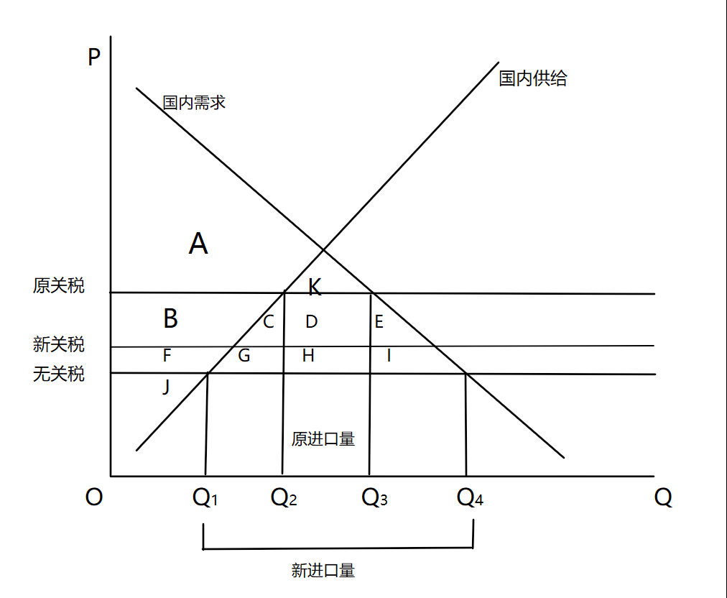

**Consumer surplus:** Formal: A+K Now: A+B+C+D+E+K

**Producer surplus:** Formal: B+F+J Now: F+J

**Government revenue:** Formal: D+H Now: H

**Dead-weight loss:** Formal: C+E+G+I Now: G+I

Consumer surplus increases

Producer surplus decreases

Reduced government revenue

Dead-weight loss has decreased and social welfare has increased.

Efficiency increases

Because imported goods occupy the market of some domestic commodity producers, the competition in the domestic commodity market may be intensified and the unemployment rate may rise as well.

1. **For domestic commodity producers:**

On the one hand, for those enterprises that import raw materials and equipment for production, tariff reduction means lower production costs. They can acquire raw materials and equipment for production at lower prices, reduce fixed and variable costs, which is conducive to expanding production, further developing economies of scale, increasing profits and improving market competitiveness;

On the other hand, for those producers whose products compete with imported goods, tariff reduction means that more imported goods will enter the market, and the prices of these goods are lower than the past, which will lead to a more intensified market competition, weaken the price advantage of domestic producers, and decrease their sales volume and market share, which may reduce the income of some domestic producers. Reducing tariff may bring negative externality to some suppliers.

1. **For consumers:**
2. The price of imported goods has dropped, reducing the economic burden on consumers. Under the influence of income effect, the decrease of commodity price increases the purchasing power of consumers' income, the budget constraint line moves outward, the indifference curve moves upward, and consumers get more satisfaction. Under the influence of substitution effect, consumers will increase the purchase of imported goods, which promotes the further development of international trade.
3. With the increasing competition in the domestic commodity market, consumers are faced with more diversified products, from which they can choose the best combination of goods, obtain high-quality goods at a lower price, and improve the quality and level of consumption. Reducing tariff has positive externality to consumers.
4. **Summary**

China's decision of reducing import tariffs has both positive and negative effects. But on the whole, this decision is conducive to promoting China's economic development、the improvement of people's living standards and the development of international trade. All in all, it is a beneficial economic decision.

**Newspaper Article #3 by 范雨萱**

# Article Title：明后年猪肉价格或再下探 非洲猪瘟影响猪周期

# 关税调降助推，业界预计明年猪肉进口量达250万吨

Article link [:](https://www.sohu.com/a/433033563_100191067?scm=1019.e000a.v1.0&spm=smpc.csrpage.news-list.1.1608989063885CxkiGkE)

<https://www.sohu.com/a/433033563_100191067?scm=1019.e000a.v1.0&spm=smpc.csrpage.news-list.1.1608989063885CxkiGkE>

[HTTP://baijiahao.baidu.com/s?id=1653804112374532291&wfr=spider&for=pc]("https://www.sohu.com/a/433033563_100191067?scm=1019.e000a.v1.0&spm=smpc.csrpage.news-list.1.1608989063885CxkiGkE)

Microeconomics concept discussed:

1. Demand and supply 2.Government policy

3.Factors affecting price 4.substitution effect

5.Is continuous high price good for firms 6.Import and tariff

Analysis:

**1.demand and supply**

There are six factors that affect the change of demand: the price of related products, the expected future price, income level, the expected future income level, population and preference.

There are five factors that affect the change of supply: the price of production resources, the price of related products, the expected future price, the number of suppliers and technology.

Because of the impact of swine plague at home and abroad, the production of live pigs decreased, the supply curve moved to the left, and the consumer demand for pork did not decrease, leading to the rise of pork prices.

In the Spring Festival and other special holidays, due to the increase of people's demand, the demand curve moves to the right, while the supply of live pigs remains unchanged, which will also lead to the rise of pork prices in the short term.

These reflect the relationship between supply and demand and the impact of supply and demand on prices.The chart below shows the impact of classical swine fever on prices.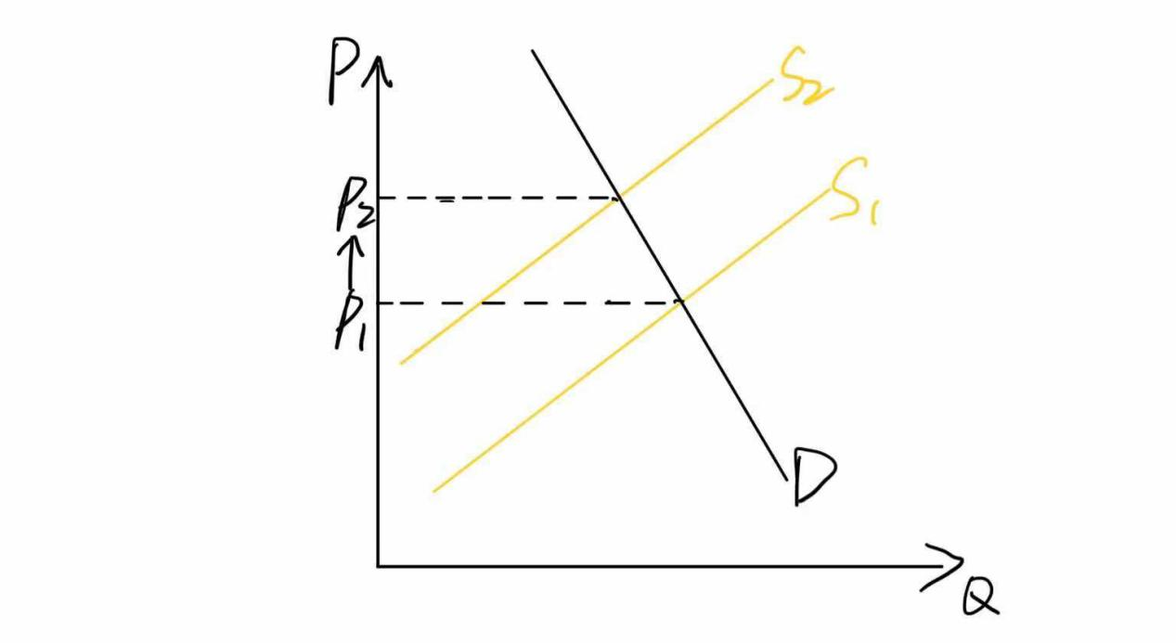

**2.Government policy**

In a free and unregulated market, market forces determine the equilibrium price and the quantity of sales. The equilibrium price may not satisfy everyone. The government usually considers that the equilibrium price is unfair to the buyer or the seller.

In the face of rising pork prices, the government has issued some policies to stabilize prices and protect people's livelihood.

For example, increasing subsidies for pig breeding ,and setting price ceiling,which will cause a certain amount of shortage .The chart below shows what will happen if the government sets a price ceiling.Market demand will exceed market supply.

Price control often hurts the people it wants to help, so it can be replaced by alternative policies. It also explains that subsidies may be better than price controls.

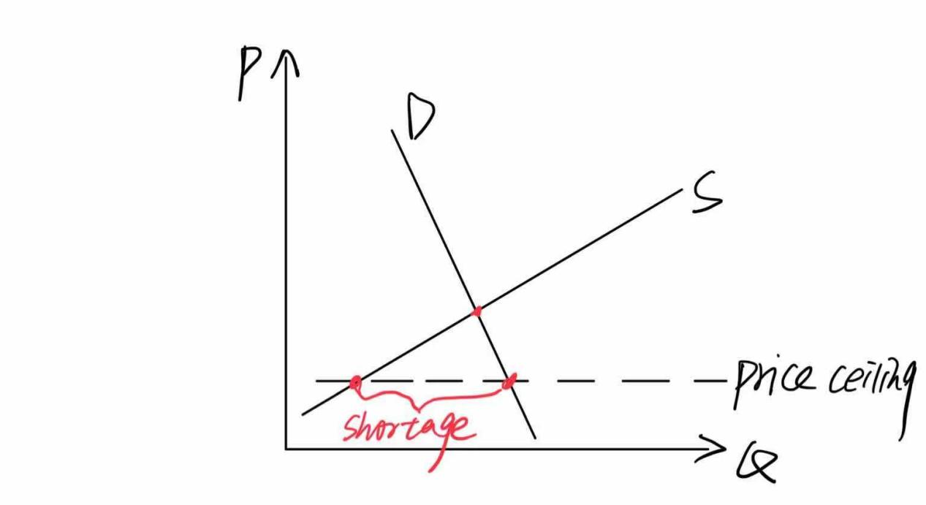

**3.Factors affecting price**

There are many factors that affect the price, including price changes of complementary products and substitutes, changes of consumer behavior, expectations, relationship between supply and demand.A small part of pork is caused by African swine fever, environmental protection policies, market changes and cyclical fluctuations of pigs. At present, the decline of pork price is also the result of many factors.

**4.Substitution effect**

The total effect of demand change caused by the price change of a commodity can be divided into substitution effect and income effect.

When the relative price or opportunity cost of a commodity rises, people will buy its substitutes, so the demand for the commodity or service will decline.

The rising price of pork will make consumers reduce the demand for pork and turn to buy similar products, namely pork substitutes. Take pork and chicken, When the price of pork rises obviously, the price of chicken remains stable, for example, there will be a substitution effect.From point A to point B is the substitution effect.

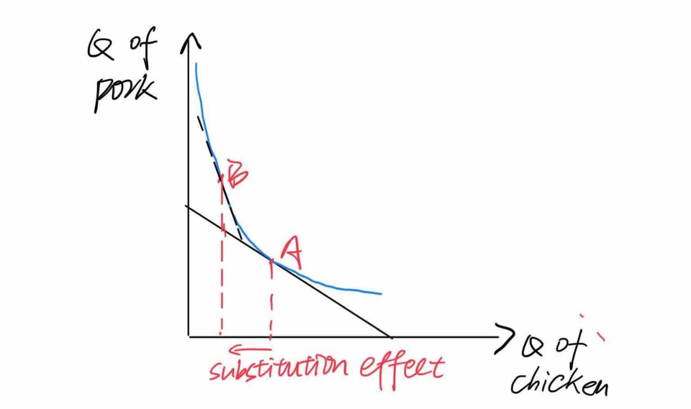

**5.Is continuous high price good for firms**

Sustained high prices are not a good thing for companies, because high profits will encourage more enterprises to enter the market, leading to higher supply and lower prices.Too high a price is not necessarily good for an enterprise. After the price was too high, a large number of enterprises came in and soon put the price down.If in the long-term perfect competition market, the enterprise's profit will adjust and finally equal to zero.

**6.Import and tariff**

Because of the large domestic demand for pork, the domestic pork supply is insufficient. What will happen when the country reduces the import tariff on pork is shown in the chart below.

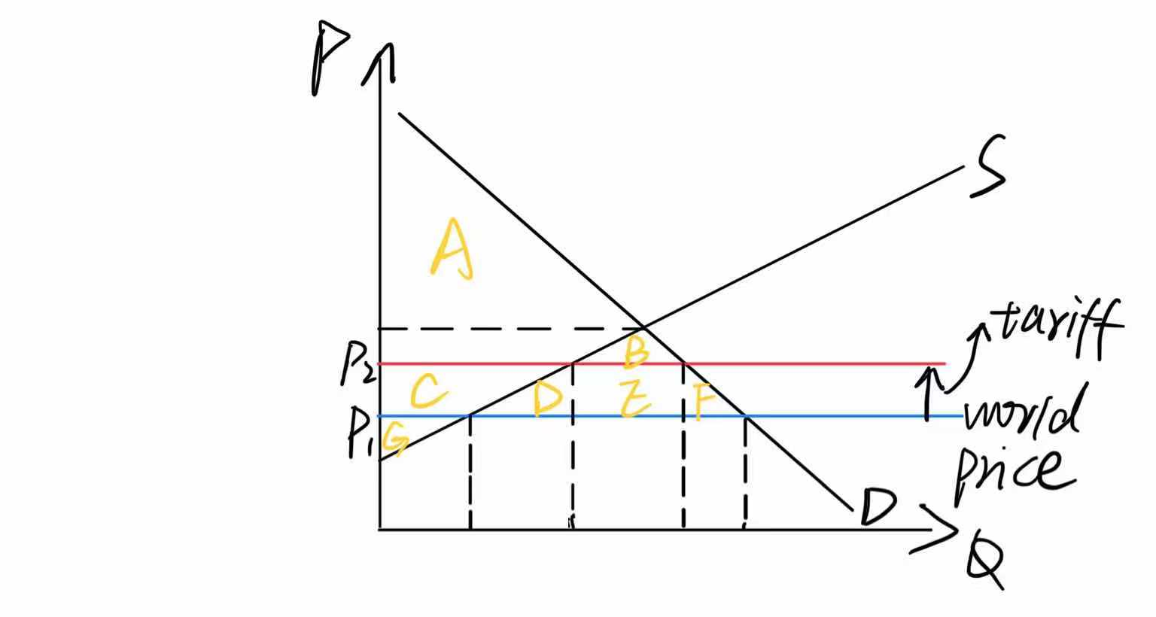

|  |  |
| --- | --- |
|  | After tariff |
| Consumer surplus | A+B |
| Producer surplus | C+G |
| Government revenue | E |
| Total surplus | A+B+C+G+E |
| DWL | D+F |

If the government reduces tariffs, the red line will move down, resulting in an increase in consumer surplus and a decrease in government revenue and producer surplus.It also reduces DWL. Of course, it can reduce the price of imported pork and relieve the pressure of domestic pork market.Increase in imports

**7.Summary**

Pig cycle is a kind of economic phenomenon, which refers to the cycle of pork price change. The circulation track of "pig cycle" is generally as follows: high meat price - large increase of sow stock - increase of pig supply - decrease of meat price - large elimination of sows - decrease of pig supply - increase of meat price.

The high price of pork stimulates the enthusiasm of farmers, resulting in the increase of supply. The increase of supply leads to the decline of meat price. When the meat price falls to a very low level, it hits the enthusiasm of farmers, resulting in the shortage of supply. The shortage of supply makes the meat price rise again and again, which forms the so-called "pig cycle".

In recent ten years, China has experienced three pig cycles. These three cycles were all caused by epidemic disease and overcapacity. Then, after the pig price fell below the breeding cost line, it was accompanied by the state's intervention and disease rescue. After a long-term decline in breeding costs, the industry began to reduce production on a large scale, so the next round of pig cycle has been brewing since then.

No matter how the price of pork fluctuates, it is essentially driven by the relationship between supply and demand.

## **Newspaper Article #4 by 宋浩楠**

### Article Title: 中美贸易战

Article URL:  [HTTP://m.yebaike.com/22/2599349.html](https://www.yebaike.com/22/2599349.html)

Microeconomics concept discussed: Trade

**At the beginning of the discussion**

　we must admit that there is competition between China and the United States in trade. Because Chinese enterprises and American enterprises will produce many identical products, they will compete for the same customers in clothing, toys, automobile tires and many other goods markets. At the same time, with the rise of China in the field of high-end science and technology, the high-end electronic technologies, such as smart phones and artificial intelligence, sold by China to the world market have had a certain impact on the domestic and international markets of the United States.

**Trade make everyone batter off**

However, in fact, we must realize that the trade between the two countries can make the situation between the two countries better (one of the ten principles of economics k). Just as for individuals, trade can enable everyone to engage in their best activities. At the same time, by trading with others, people can obtain various goods and services with lower products. For countries, trade can enable countries to specialize in their best activities and enjoy more kinds of products and services. When China and the United States trade, China can seize the domestic production in the United States at a lower price by relying on its own cheap labor and large-scale production of daily necessities, while the United States can monopolize the chip market in China by relying on its own high-end technology. At the same time, in the trade exchange between China and China, both sides can further upgrade their own industrial products with their own learning ability.

（１）Comparative advantage

On the other hand, the reason for trade between China and the United States is based on comparative advantage. The outbreak of Sino-US trade war is essentially one of the reasons why the United States mistakenly regards its absolute superiority as one of the reasons for refusing trade. Because of the leading strength of American science and technology, the United States has the advantages of other countries in many aspects, and can obtain high-quality output with less investment. This is similar to the "anti-trade globalization" advocated by many scientific and technological powers such as the West. They all regard their absolute advantage in international trade as the essential reason to measure their trade level, while ignoring the comparative advantage with opportunity cost as the core. Although a big technological country like the United States can achieve self-sufficiency to a certain extent, a completely closed environment will definitely make them lose more. Therefore, the normalization of Sino-US trade can enable both China and the United States to engage in economic activities that they are good at according to their comparative advantages, thus gaining more prominent economic benefits.

（２）Economic welfare

In terms of economic welfare, the above viewpoint is still correct. Both the United States and China appear in international trade as big trading countries. When the two sides trade, there will be many different fields at the same time. As far as the United States is concerned, the trade between China and the United States includes not only the export of related high-end products, but also the import of basic living and industrial products. We use consumer surplus and producer surplus to measure economic welfare here. In the American export market, the domestic price of American related goods is lower than the international price. With such advantages, the United States can wantonly export its domestic products to other countries and make huge profits from them. This is the main reason why the United States led the world economic globalization in the early stage. However, in the import market, the United States thinks that China's cheaper products have a huge impact on the local industrial structure of the United States. However, this view ignores the consumer surplus caused by imported goods to American domestic consumers. Therefore, the deterioration of Sino-US trade war actually harms the interests of American people.

进口国

出口国

（３）Customs

From the perspective of customs, the trade impact of Sino-US trade war remains unchanged. We all know that the Sino-US trade war started, to a great extent, because of the tariff. Unilaterally, the U.S. government thinks that China has dumped its goods when exporting to the United States, so it forcibly raises tariffs on Chinese goods in violation of international trade rules. However, when we analyze the economic benefits generated by this result, this practice in the United States will still lead to the reduction of its total social surplus. As shown in the figure below, the US behavior of raising tariffs has caused more unnecessary losses.

To sum up, the occurrence of Sino-US trade war has seriously hindered the trade between the two countries, and at the same time, it is aimed at the United States. On the one hand, the behavior of raising tariffs by the United States has not only failed to get the United States out of trouble, but also plunged the United States into a deeper quagmire.

**Newspaper Article#5by甘越彤**

Article Title: Demand-side reform on 2021 policy agenda

Article URL:

[HTTP://epaper.chinadaily.com.cn/a/202012/16/WS5fd93d72a31099a234352905.html]("HTTP://epaper.chinadaily.com.cn/a/202012/16/WS5fd93d72a31099a234352905.html)

Microeconomics concept discussed: Demand, Taxes

Prioritize boosting domestic demand and cementing the acceleration in consumer spending as it sets out the major economic tasks for 2021

**1. Demand**

(1)Definition of demand

Let’s begin at the definition of demand. Demand is the entire relationship between the price and quantity demanded of the good during a particular time period.

(2)Market equilibrium

Demand and supply determine the market equilibrium together. It is a situation in which the market price has reached the level at which quantity supplied equals quantity demanded. Any change in supply or demand will influence the market equilibrium. In this part, we will place emphasis on the result influenced by demand increasing.

(3)Changes in demand curve

When we concern the increase of demand, what we focus on is the shift of demand curve, then it will change the equilibrium. Presuming other things remain the same, if demand increases, the demand curve shifts rightwards. Market equilibrium increases along the supply curve, at this time, the price and quantity supply increases. At the original price, there will be a shortage, which incurs producers make the decision of increasing the supply. Then supply curve shifts rightwards too. The increase in the number of goods makes up for the shortage, meets the consumers’ needs, promoting the economic growth. The same, if there is a surplus in the market, increase in demand can also reduce the surplus and reach the market equilibrium.

Let’s have a look at the following two figures.

The first figure shows the situation when the demand of the products increases and the result of shortage.

The second figure shows the shift of supply curve.(The changed market equilibrium is not necessarily equals the former because the increase in demand raises the price and the increase in supply lowers it.)

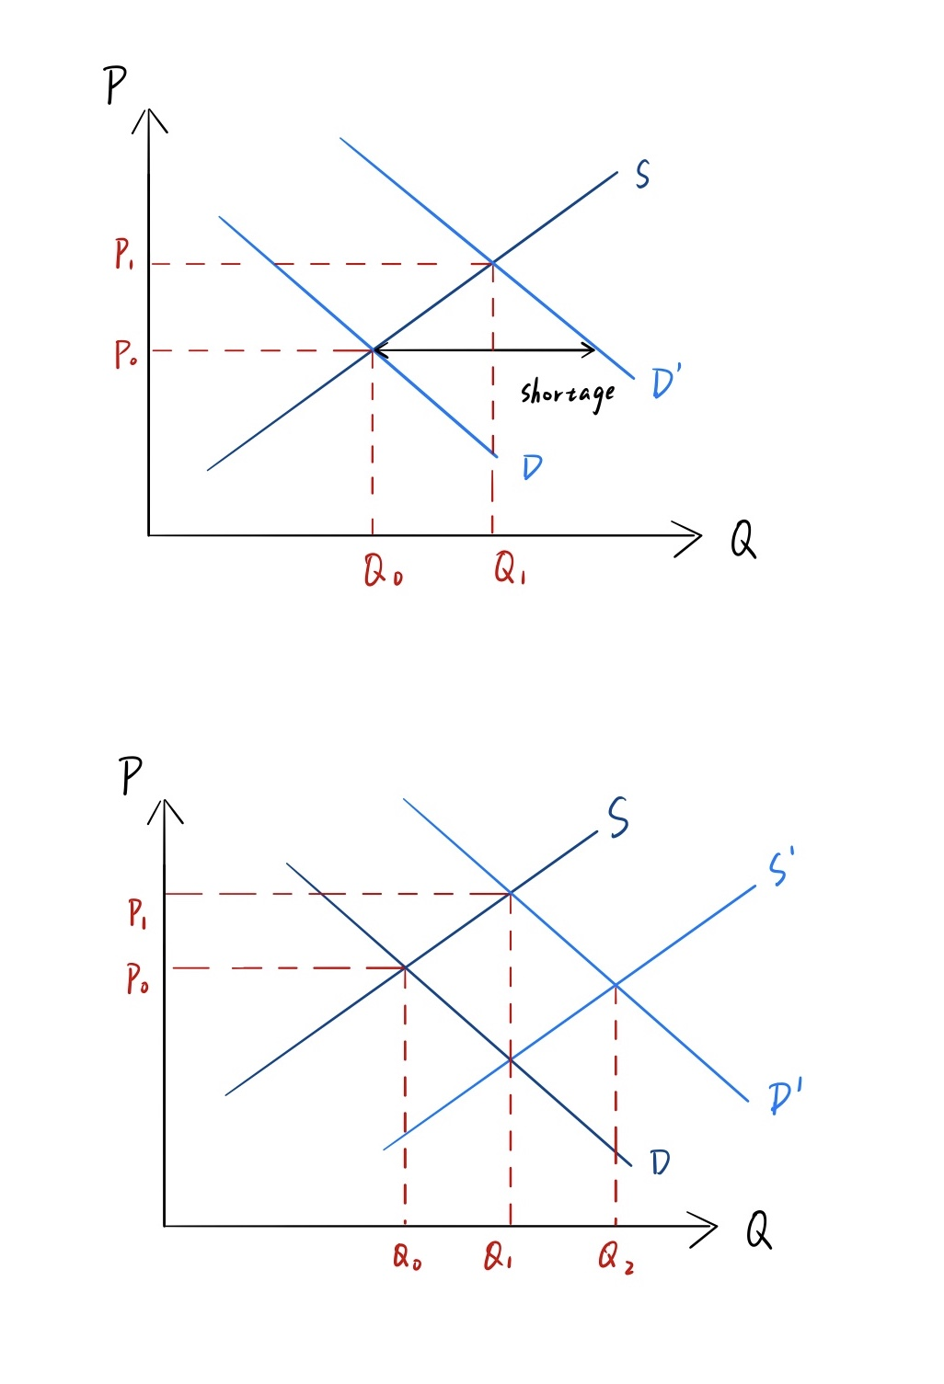

(4)Combination with news report

Domestic demand, which means consumer demand and investment demand, has been mentioned for many times this year. (We talk about the consumer demand now.) Influenced by the serious epidemic and the uncertainty of external environment, the economic developments of many countries are slow, stagnant or even negative. In terms of epidemic situation, most firms have the phenomenon of stockpiling of unsold products, and even facing the risk of exiting the market. If the policy of boosting domestic demand is effective, it can make up for the surplus, then firms can recover the cost, preventing from exiting the market. In the long run, it also can reach the equilibrium.

(5)Summary

One of the principles of economics is government can sometimes improve market outcomes. The policy that prioritizes boosting domestic demand is both beneficial to consumers and producers. What’s more, because demand fuels the economic growth, then promoting supply upgrading, by this way, we can maintain economic steady growth and make structural adjustments.

**2. Taxes**

(1)The relationship between taxes and demand or supply

If government reduces the tax on consumers or sellers appropriately, it will stimulate the willingness for buyers and sellers to buy or produce.

(2)Analysis of tax revenue

For example, presume we conduct analysis of the tax revenue. Given the demand curve and supply curve, we will discuss three situations of the small tax(the first graph), medium tax(the second graph) and large tax(the third graph). The information what we can gain from the following graphs is that when government imposes small tax(the first graph), though government revenue just increases slightly, the deadweight loss is small. Also, the burden on consumers and producers is small too. Naturally, it can promote consumption, thus decrease the loss of producers from excess production.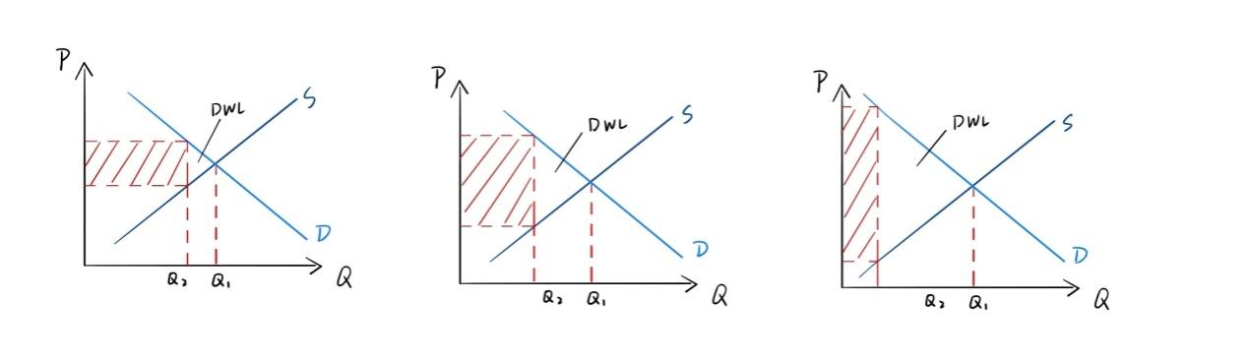

(3)Individual income tax

As we all know, individual income tax is deducted from our salary, if government reduce the impose on income tax, consumers’ income will increase. When income increases, demand curve will shift. What we talk about is a normal good now, then the demand curve will shift rightwards along with increasing income. At this time, the discussion comes back to what we have talked about above.

(4)Summary

Although there are many ways to boost domestic demand, we just focus on the influence of taxes. From the discussion before, we can know the changes in the amount of tax can affect the demand and supply. It is also one of the manifestations of government intervention in the market.

**3. Conclusion**

In order to restore the China economic during the epidemic time and complex external environment, China government puts forward the policy of boosting domestic demand and cementing the acceleration in consumer spending as it sets out the major economic tasks for 2021. Analyze from the two aspects, the policy is beneficial to the consumers, the producers and the whole country.

## **References:**

1. 蚂蚁上市被紧急叫停，一夜之间，马云的世界变了天！

from <https://new.qq.com/rain/a/20201105A0CWF200>

2.2021年1月1日起我国调整部分商品进口关税

from <http://www.xinhuanet.com/2020-12/23/c_1126897341.htm>

1. 明后年猪肉价格或再下探 非洲猪瘟影响猪周期

关税调降助推，业界预计明年猪肉进口量达250万吨

from<https://www.sohu.com/a/433033563_100191067?scm=1019.e000a.v1.0&spm=smpc.csrpage.news-list.1.1608989063885CxkiGkE>

[HTTP://baijiahao.baidu.com/s?id=1653804112374532291&wfr=spider&for=pc]("https://www.sohu.com/a/433033563_100191067?scm=1019.e000a.v1.0&spm=smpc.csrpage.news-list.1.1608989063885CxkiGkE)

### 4.中美贸易战

from  [HTTP://m.yebaike.com/22/2599349.html](https://www.yebaike.com/22/2599349.html)

5.Demand-side reform on 2021 policy agenda

from[HTTP://epaper.chinadaily.com.cn/a/202012/16/WS5fd93d72a31099a234352905.html]("HTTP://epaper.chinadaily.com.cn/a/202012/16/WS5fd93d72a31099a234352905.html)

**[Group members:]("HTTP://epaper.chinadaily.com.cn/a/202012/16/WS5fd93d72a31099a234352905.html)**

[钟娇 罗梓劲 范雨萱 宋浩楠 甘越彤 (edited by 钟娇）]("HTTP://epaper.chinadaily.com.cn/a/202012/16/WS5fd93d72a31099a234352905.html)

---- END OF REPORT ----